**Ex No 7**

**Implement Linear and Logistic Regression in R**

**AIM:**

To Implement Linear and Logistic Regression using R

**PROCEDURE:**

* Collect and load the dataset from sources like CSV files or databases.
* Clean and preprocess the data, including handling missing values and encoding categorical variables.
* Split the dataset into training and testing sets to evaluate model performance.
* Normalize or standardize the features to ensure consistent scaling. 5.Choose the appropriate model: Linear Regression for continuous outcomes. ● Train the model on the training data using the `fit` method.
* Make predictions on the testing data using the `predict` method.
* Evaluate the model using metrics like Mean Squared Error (MSE) for Linear Regression or accuracy and confusion matrix for Logistic Regression.
* Visualize the results with plots, such as scatter plots for Linear Regression or decision boundaries for Logistic Regression.
* Fine-tune the model by adjusting hyperparameters or applying regularization Techniques.

**CODE:**

**LinearRegression.R:**

# Sample data heights <- c(150, 160, 165, 170, 175, 180, 185) weights <- c(55, 60, 62, 68, 70, 75, 80)

# Create a data frame data <- data.frame(heights, weights) # Fit a linear regression model linear_model <- lm(weights ~ heights, data = data)

# Print the summary of the model print(summary(linear_model)) # Plotting the data and regression line plot(data$heights, data$weights, main = "Linear Regression: Weight vs. Height", xlab = "Height (cm)", ylab = "Weight (kg)", pch = 19, col = "blue")

# Add regression line

abline(linear_model, col = "red", lwd = 2) **LogisticRegression.R:**

# Load the dataset data(mtcars)

# Convert 'am' to a factor (categorical variable) mtcars$am <- factor(mtcars$am, levels = c(0, 1), labels = c("Automatic", "Manual"))

# Fit a logistic regression model logistic_model <- glm(am ~ mpg, data = mtcars, family = binomial)

# Print the summary of the model print(summary(logistic_model)) # Predict probabilities for the logistic model predicted_probs <- predict(logistic_model, type = "response")

# Display the predicted probabilities print(predicted_probs)

# Plotting the data and logistic regression curve plot(mtcars$mpg, as.numeric(mtcars$am) - 1,

main = "Logistic Regression: Transmission vs. MPG", xlab = "Miles Per Gallon (mpg)", ylab = "Probability of Manual Transmission", pch = 19, col = "blue") # Add the logistic regression curve curve(predict(logistic_model, data.frame(mpg = x), type = "response"), add = TRUE, col = "red", lwd = 2)

**OUTPUT:**

**Linear Regression:**

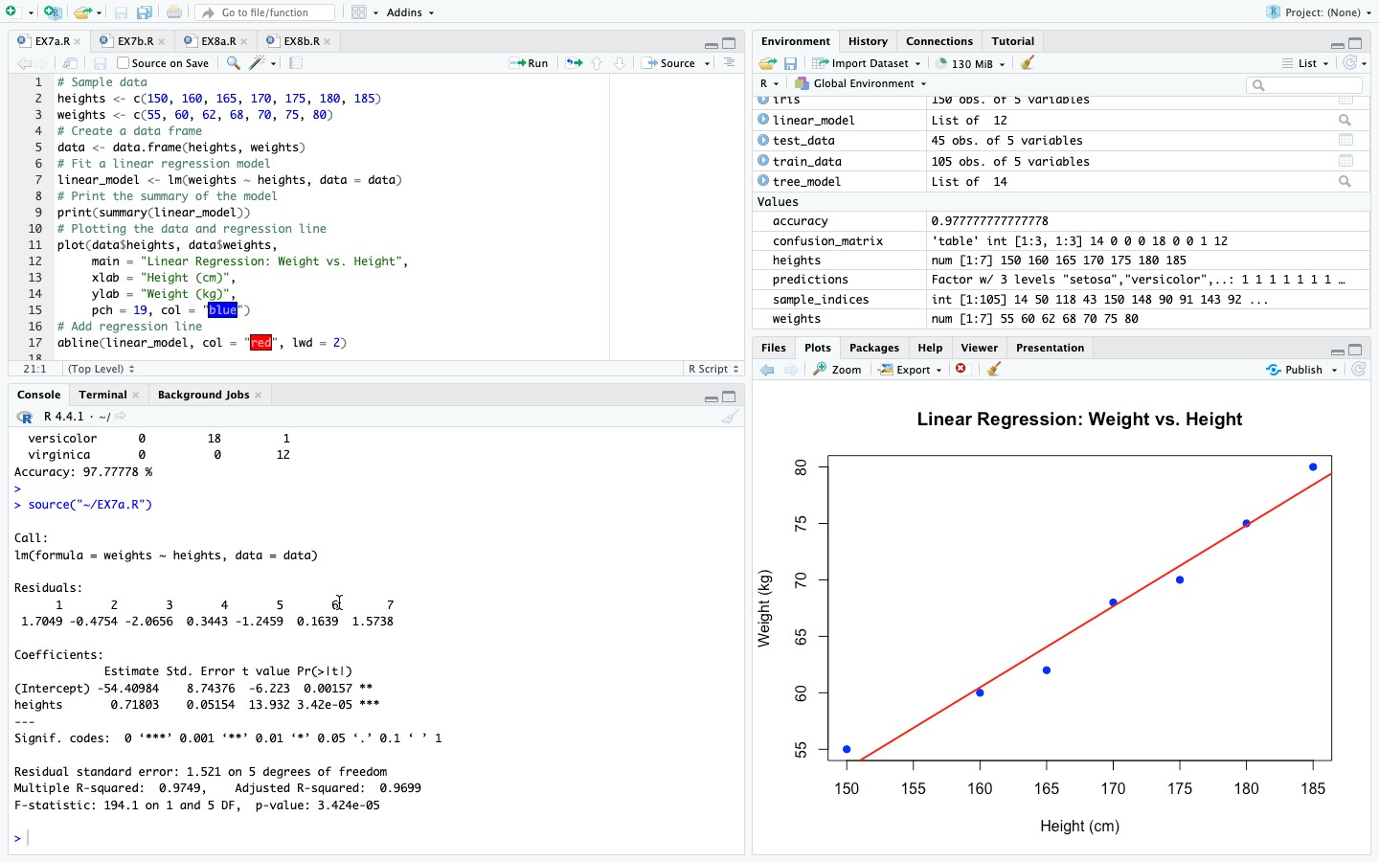

**Logistic Regression:**

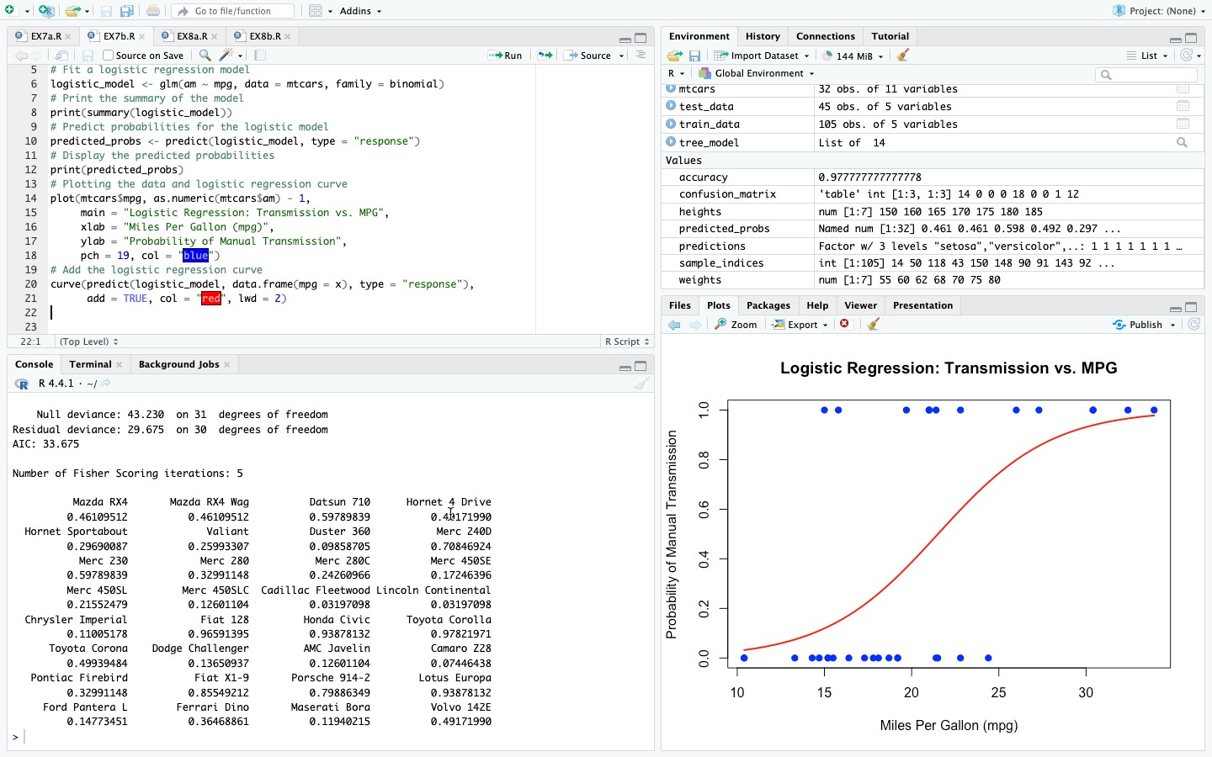

**RESULT:**

Thus to Implement Linear and Logistic Regression using R has been successfully executed.